Python Game Programming: Rock Paper Scissors


Submitted by:
Hafsa Shahban
(016030/BSCMAI/F25)
Rameesha bibi
(016093/ BSCMAI /F25 )
Wajeeha Amjad
(016095/ BSCMAI /F25 )
Razia Ashraf
(016526/ BSCMAI /F25 )

Submitted to:
Dr. Farhan Khan

Faculty of Sciences
Department:Mathematics and Statistics
International Islamic University Islamabad

In this project, we are going to make a “Rock Paper Scissors” game. Below are the game rules:
- Rock smashes scissors.
- Paper covers rock.
- Scissors cut paper.
- If both choose the same option, the round becomes a draw.

Introduction
This project is a simple Rock Paper Scissors Game made in Python.
The game is played between the user and the computer.
The computer chooses randomly between rock, paper, and scissors using Python’s random module.
The game contains:
- User input validation
- Multiple rounds
- Score tracking
- Winner checking
- Replay option

Tools & Concepts Used:

1. Python Language
The entire game is developed using Python programming language.

2. Random Module
import random
The random module is used to let the computer choose a random option.
Example:
random.choice(choices)
This randomly selects:
- rock
- paper
- scissors
from the list.

Program Working

Step 1: Import Random Module
import random
This line imports the random module so the computer can make random choices.

Step 2: Welcome Message
print("Welcome to Rock Paper Scissors Game")

This displays the starting message of the game.

Step 3: Create Choices List
choices = ["rock", "paper", "scissors"]
A list is created containing all valid game options.

Functions Used
The program uses functions to organize the code properly.

1. get_user_choice()
def get_user_choice():

Purpose

This function takes input from the user.

Working
- Asks the user to enter:
  - rock
  - paper
  - scissors
- Converts input to lowercase using .lower()
- Removes extra spaces using .strip()
- Checks whether input is valid
- Repeats until correct input is entered

Example

Benefit
This prevents invalid inputs and makes the program user-friendly.
2. get_winner(user, computer)
def get_winner(user, computer):

Purpose
This function decides the winner of one round.

Parameters
- user → user choice
- computer → computer choice

Working
- Checks if both choices are same → draw
- Checks all winning conditions for user
- Otherwise computer wins

Winning Conditions
(user == "rock" and computer == "scissors")
(user == "paper" and computer == "rock")
(user == "scissors" and computer == "paper")

Return Values
The function returns:
- "draw"
- "user"
- "computer"

3. play_round()
def play_round():

Purpose
This function controls multiple rounds of the game.

Features
- Keeps track of scores
- Runs maximum 5 rounds
- Ends early if someone reaches 3 points

Variables Used
user_score = 0
computer_score = 0
max_rounds = 5
current_round = 0

Working
- Starts loop for rounds
- Gets user and computer choices
- Calls get_winner()
- Updates scores
- Displays current score
- Stops game if any player reaches 3 wins

Example
if user_score == 3 or computer_score == 3:
break
This stops the match early when someone wins 3 rounds.

Return Value
return user_score, computer_score
The function returns final scores.

4. play_game()
def play_game():

Purpose
This is the main function of the program.

Working
- Calls play_round()
- Displays final match result
- Checks overall winner
- Asks user to replay the game

Replay Feature
If user enters anything other than "yes", the game stops.

Loops Used

While Loop
while True:
This loop keeps the game running until the user decides to stop.
Another while loop is used for rounds:
while current_round < max_rounds:
This controls the total number of rounds.

Conditions Used
The program uses:
- if
- elif
- else
statements for:
- checking inputs
- deciding winners
- displaying results

Functionalities of the Program
The game includes the following functionalities:
Random computer choices
Input validation
Score tracking
Multiple rounds
Early win condition
Match result display
Replay option
Proper function-based structure

How to Run the Program

Step 1

Open Google Colab in your browser.

Step 2

Create a new Python notebook.

Step 3

Copy and paste the Rock Paper Scissors game code into a code cell.

Step 4

Click the Run button to execute the program.

Step 5
Enter rock ,paper or scissors when the program asks for input.

Step 6
Play the game and choose whether to restart after the match ends.

Output Example
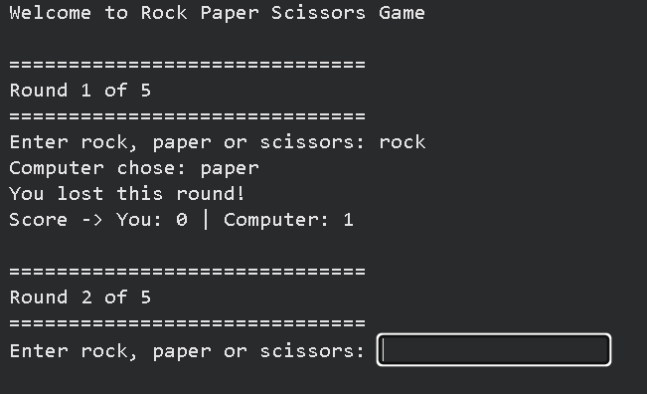

Conclusion:
This Rock Paper Scissors game is a simple Python project that demonstrates:
- functions
- loops
- conditions
- user input handling
- random module usage

